

**FLY AWAY PLUS**

**DETAIL DESIGN DOCUMENT**

**Data Design**

**Project Code: FAP**

**Document Code: FAP_Data Design_v1.1_EN**

**Record of Change**

*A-Added M-Modified D-Deleted

|  |  |  |  |  |
| --- | --- | --- | --- | --- |
| Date | Item | A, M, D* | Change Description | Version |
| 2015/08/14 | Add new | A |  | V1.0 |
| 2015/08/20 | Overview  Entity Relationship Diagram | M |  | V1.1 |

Table of Contents

1. Introduction 4

1.1. Purpose 4

1.2. Definitions, Acronyms and Abbreviations 4

1.3. References 4

1.4. Overview 4

2. Database 4

2.1. Entity Relationship Diagram 4

2.1.1. Entity Description 7

2.1.2. Relationship 7

2.2. Table Diagram 8

2.2.1. User Table 8

2.2.2. Comment Table 10

2.2.3. Conversation Table 10

2.2.4. Message Table 10

2.2.5. Notification Table 10

2.2.6. Post Table 11

2.2.7. Place Table 11

2.2.8. Photo Table 11

2.2.9. Video Table 12

2.2.10. Room Table 12

2.2.11. Report Post table 12

2.2.12. Report User table 13

# Introduction

## Purpose

Fly Away Plus data design document describes structure of database and file structure of system including internal file structure as well as interface file structure.

## Definitions, Acronyms and Abbreviations

|  |  |  |
| --- | --- | --- |
| Abbreviations | Description | Comment |
| FAP | Fly Away Plus |  |

## References

|  |  |
| --- | --- |
| Documen | Title |
| Class Design Document | FAP_Class Design_v1.0_EN |
| Architecture Design | FAP_Architecture Design_v1.2_EN |
| Software Requirement Specification | FAP_Software Requirement Specification_v1.2_EN |

## Overview

This document describes relationship between entities and properties of each entity.

# Database

## Entity Relationship Diagram

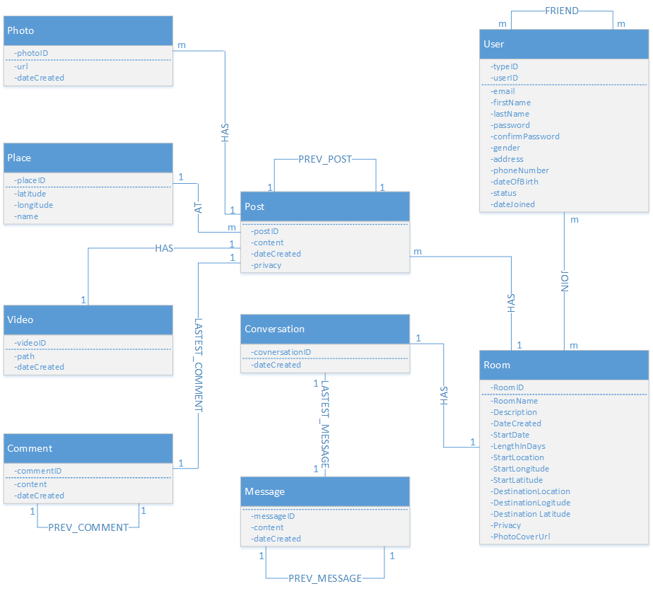

*Entity Relationship Diagram part 1*

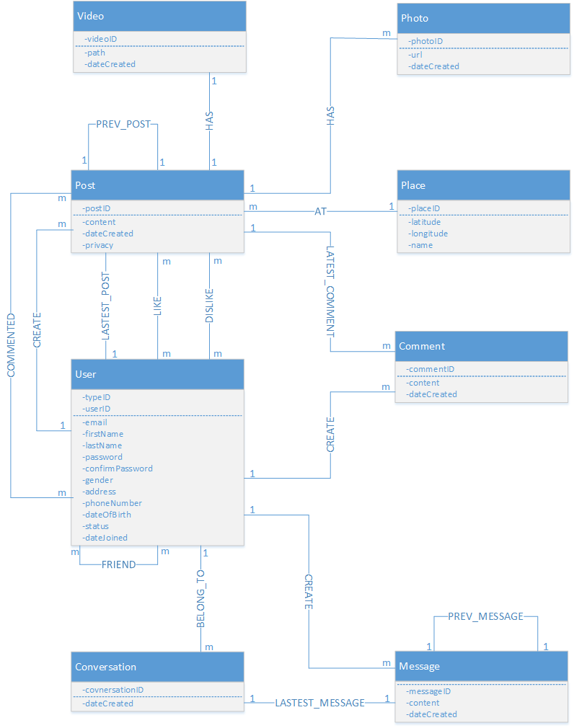

*Entity Relationship Diagram part 2*

### Entity Description

|  |  |  |
| --- | --- | --- |
| No. | Entity | Description |
|  | User | User is all people who registered and using FAP |
|  | Post | A post which user published, contain content, videos, photos and places mention |
|  | Video | A video which user attached in a post while creating |
|  | Photo | Photo(s) which user attached in a post while creating |
|  | Place | A place which user must mention in a post while creating |
|  | Room | A group which user created, includes content, plan, members, photo, video and place mention |
|  | Message | Chat is message user sends or receives from others |
|  | Comment | A comment which user created, is placed in and associated to a post |

### Relationship

|  |  |  |  |  |  |
| --- | --- | --- | --- | --- | --- |
| No. | Relation | Properties | From | To | Description |
|  | AT | None | Post | Place | A place that a post mentioned to |
|  | BELONG_TO | None | Conversation | User | A conversation which was created by an user |
|  | COMMENTED | dateCreated  activityID | User | Post | A post which user commented in  “dateCreated”: created time |
|  | CREATE | None | User | Post | A post which was created by an user |
|  | CREATE | None | User | Comment | A comment which was created by an user |
|  | CREATE | None | User | Message | A message which was created by an user |
|  | FRIEND | dateCreated  activityID | User | User | Two users are friend, exist in each others’ friend list  “dateCreated”: accepted friend request time |
|  | HAS | None | Post | Video | A post includes a videos |
|  | HAS | None | Post | Photo | A post includes photos |
|  | HAS | None | Room | Conversation | A room includes conversation |
|  | JOIN | None | User | Room | User join a room  Type 0: Admin  Type 1: Member  Type 2: Request join |
|  | LASTEST_COMMENT | None | Post | Comment | The lastest comment of a post |
|  | LASTEST_MESSAGE | None | Conversation | Message | The lastest message of a conversation |
|  | LASTEST_POST | None | User | Post | The lastest post user has created |
|  | LASTEST_POST | None | Room | Post | The lastest post which was created in room |
|  | PREV_COMMENT | None | Comment | Comment | Previous comment of a comment |
|  | PREV_MESSAGE | None | Message | Message | Previous message of a message |
|  | PREV_POST | None | Post | Post | Previous post of a post |
|  | VISITED | None | User | Place | A place which user was visited |
|  | WISH | None | User | Place | A place which was added int user wish list |

## Table Diagram

### User Table

|  |  |  |  |  |
| --- | --- | --- | --- | --- |
| No | Field Name | Type | Allow Null | Description |
|  | userID | int | No | User’s ID |
|  | typeID | int | No | User’s created type includes: normal, Facebook and Google+ resgistered |
|  | email | String | No | User’s email |
|  | firstName | String |  | User’s first name |
|  | lastName | String |  | User’s last name |
|  | password | String | No | User’s password |
|  | confirmPassword | String | No | User retypes password. Must be same as password. |
|  | address | String |  | User’s address |
|  | gender | String |  | User’s gender |
|  | phoneNumber | String |  | User’s phone number |
|  | dateOfBirth | String |  | User’s date of birth |
|  | status | String |  | User’s status |
|  | dateJoined | String | No | User’s joined date |
|  | avatar | String |  | User’s avatar |

### Comment Table

|  |  |  |  |  |
| --- | --- | --- | --- | --- |
| No | Field Name | Type | Allow Null | Description |
|  | commentID | int | No | Comment’s ID |
|  | content | String | No | Comment’s content |
|  | dataCreated | String | No | Comment’s created date |

### Conversation Table

|  |  |  |  |  |
| --- | --- | --- | --- | --- |
| No | Field Name | Type | Allow Null | Description |
|  | conversationID | String | No | Conversation’s ID |
|  | dataCreated | String | No | Conversation’s created date |

### Message Table

|  |  |  |  |  |
| --- | --- | --- | --- | --- |
| No | Field Name | Type | Allow Null | Description |
|  | messageID | int | No | Message’s ID |
|  | content | String | No | Message’s content |
|  | dateCreated | String | No | Message’s created date |

### Notification Table

|  |  |  |  |  |
| --- | --- | --- | --- | --- |
| No | Field Name | Type | Allow Null | Description |
|  | lastActivityID | int | No | Notification’s ID |
|  | activity | String | No | Notification’s activity |
|  | dateCreated | String | No | Notification’s created date |
|  | user | user | No | Activity’s owner |
|  | post | post | No | Activity’s location |

### Post Table

|  |  |  |  |  |
| --- | --- | --- | --- | --- |
| No | Field Name | Type | Allow Null | Description |
|  | postID | int | No | Post’s ID |
|  | content | String | No | Post’s content |
|  | dateCreated | String | No | Post’s created date |
|  | privacy | String | No | Post’s privacy |

### Place Table

|  |  |  |  |  |
| --- | --- | --- | --- | --- |
| No | Field Name | Type | Allow Null | Description |
|  | placeID | int | No | Place’s ID |
|  | longitude | decimal | No | Place’s longitude |
|  | latitude | decimal | No | Place’s latitude |
|  | name | String | No | Place’s name |

### Photo Table

|  |  |  |  |  |
| --- | --- | --- | --- | --- |
| No | Field Name | Type | Default | Description |
|  | photoID | int | No | Photo’s ID |
|  | url | String | No | Photo’s url |
|  | dateCreated | String | No | Photo’s created date |

### Video Table

|  |  |  |  |  |
| --- | --- | --- | --- | --- |
| No | Field Name | Type | Allow Null | Description |
|  | videoID | int | No | Video’s ID |
|  | path | String | No | Video’s url |
|  | dateCreated | String | No | Video’s created date |

### Room Table

|  |  |  |  |  |
| --- | --- | --- | --- | --- |
| No | Field Name | Type | Allow Null | Description |
|  | roomID | int | No | Room’s ID |
|  | roomName | String | No | Room’s name |
|  | dateCreated | String | No | Room’s created date |

### Report Post table

|  |  |  |  |  |
| --- | --- | --- | --- | --- |
| No | Field Name | Type | Allow Null | Description |
|  | reportID | int | No | Report’s ID |
|  | postID | int | No | Reported post’s ID |
|  | content | String | No | Report’s reason |
|  | userReportID | int | No | Report owner’s ID |
|  | userReportedID | int | No | Reported user’s ID |

### Report User table

|  |  |  |  |  |
| --- | --- | --- | --- | --- |
| No | Field Name | Type | Allow Null | Description |
|  | reportID | int | No | Report’s ID |
|  | content | String | No | Report’s reason |
|  | userReportID | int | No | Report owner’s ID |
|  | userReportedID | int | No | Reported user’s ID |